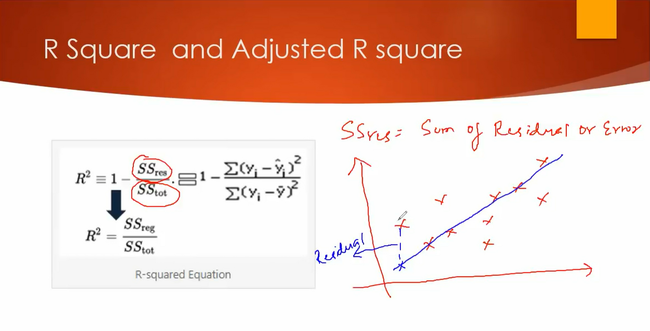

SStot = Sum of average total
R^2 is used to check the goodness of best fit line
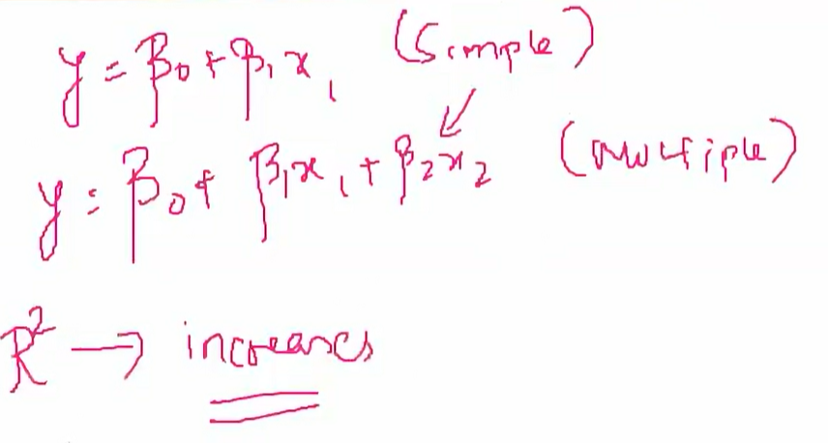
This happens when when we go on adding independent feature
To prevent this pblm we use Adjusted R^2.
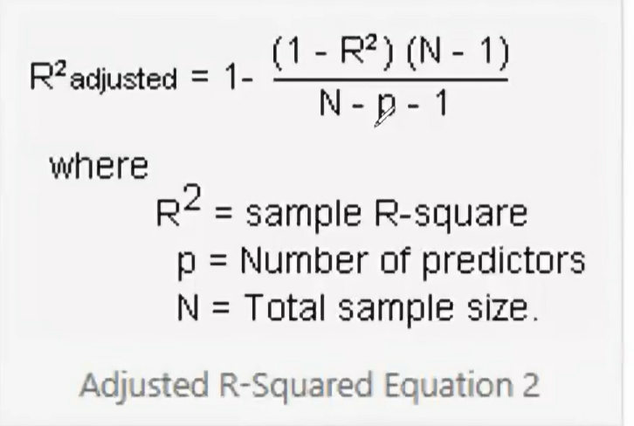
Penealises the attributes that are not correlated .
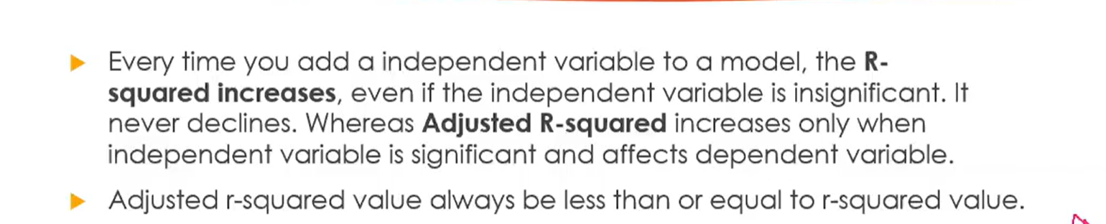
These are the diff b/w the R^2 and Adjusted R^2.

